|  |  |
| --- | --- |
| Project Title | **coffee sales** |
| Tools | ML, SQL, Excel |
| Domain | Data Analyst & Data scientist |
| Project Difficulties level | intermediate |

Dataset : Dataset is available in the given link. You can download it at your convenience.

[Click](https://drive.google.com/file/d/1YqP5Na7_o2xBwsFcf-0NTK31u5_EpxKC/view?usp=sharing) [here](https://drive.google.com/file/d/1YqP5Na7_o2xBwsFcf-0NTK31u5_EpxKC/view?usp=sharing) [to](https://drive.google.com/file/d/1YqP5Na7_o2xBwsFcf-0NTK31u5_EpxKC/view?usp=sharing) [download](https://drive.google.com/file/d/1YqP5Na7_o2xBwsFcf-0NTK31u5_EpxKC/view?usp=sharing) [data](https://drive.google.com/file/d/1YqP5Na7_o2xBwsFcf-0NTK31u5_EpxKC/view?usp=sharing) [set](https://drive.google.com/file/d/1YqP5Na7_o2xBwsFcf-0NTK31u5_EpxKC/view?usp=sharing)

# About Dataset Overview

This dataset contains detailed records of coffee sales from a vending machine. The vending machine is the work of a dataset author who is committed to providing an open dataset to the community.

It is intended for analysis of purchasing patterns, sales trends, and customer preferences related to coffee products.

# Data Collection Period

The dataset spans from March 2024 to Present time, capturing daily transaction data.

And new information continues to be added.

# Tasks

* Time Series Exploratory Data Analysis
* Next day/week/month sales
* Specific customer purchases

# Author

Yaroslav Isaienkov [@ihelon](https://www.kaggle.com/ihelon)

**NOTE :**

1. **this project is only for your guidance, not exactly the same you have to create. Here I am trying to show the way or idea of what steps you can follow and how your projects look. Some projects are very advanced (because it will be made with the help of flask, nlp, advance ai, advance DL and some advanced things ) which you can not understand .**
2. **You can make or analyze your project with yourself, with your idea, make it more creative from where we can get some information and understand about our business. make sure what overall things you have created all things you understand very well.**

**Example: You can get the basic idea how you can create a project from here**

|  |
| --- |
| Sure! Below is a step-by-step guide to performing a coffee sales analysis using Python, focusing on data cleaning and basic machine learning (ML) modeling. This example uses pandas for data manipulation and scikit-learn for machine learning. I'll assume you have a dataset named coffee_sales.csv.   1. **Data Collection**   First, ensure you have the necessary libraries installed:  bash  Copy code pip install pandas scikit-learn matplotlib seaborn   1. **Data Preparation and Cleaning**   Load and inspect the data:  import pandas as pd  # Load the dataset data = pd.read_csv('coffee_sales.csv') |

|  |
| --- |
| # Display the first few rows print(data.head())  Assume the dataset has the following columns: Date, Store, Product, Sales, Quantity, Price.  **Handling Missing Values**  # Check for missing values print(data.isnull().sum())  # Fill missing numerical values with the median data['Sales'].fillna(data['Sales'].median(), inplace=True) data['Quantity'].fillna(data['Quantity'].median(), inplace=True) data['Price'].fillna(data['Price'].median(), inplace=True)  # Fill missing categorical values with the mode data['Store'].fillna(data['Store'].mode()[0], inplace=True) data['Product'].fillna(data['Product'].mode()[0], inplace=True)  **Converting Data Types**  # Convert Date to datetime type data['Date'] = pd.to_datetime(data['Date']) |

|  |
| --- |
| # Check the data types print(data.dtypes) **Removing Outliers**  import numpy as np  # Remove outliers based on Z-score from scipy.stats import zscore  data = data[(np.abs(zscore(data[['Sales', 'Quantity', 'Price']])) < 3).all(axis=1)]  **Feature Engineering**  # Extract month and year from the Date data['Month'] = data['Date'].dt.month data['Year'] = data['Date'].dt.year  # Drop the original Date column data.drop(columns=['Date'], inplace=True)  **3. Exploratory Data Analysis (EDA)** import matplotlib.pyplot as plt import seaborn as sns |

|  |
| --- |
| # Sales over time plt.figure(figsize=(10, 6)) sns.lineplot(data=data, x='Month', y='Sales', hue='Year') plt.title('Monthly Sales Over Years') plt.show()  # Sales by store plt.figure(figsize=(10, 6)) sns.barplot(data=data, x='Store', y='Sales') plt.title('Sales by Store') plt.show()  # Sales by product plt.figure(figsize=(10, 6)) sns.barplot(data=data, x='Product', y='Sales') plt.title('Sales by Product') plt.show()  **4. Machine Learning Modeling**  **Splitting the Data** from sklearn.model_selection import train_test_split  # Define features and target variable  X = data.drop(columns=['Sales']) |

|  |
| --- |
| y = data['Sales']  # One-hot encoding for categorical variables  X = pd.get_dummies(X, drop_first=True)  # Split the data into training and test sets  X_train, X_test, y_train, y_test = train_test_split(X, y, test_size=0.2, random_state=42)  **Training a Simple Model**  from sklearn.linear_model import LinearRegression from sklearn.metrics import mean_squared_error, r2_score  # Initialize the model model = LinearRegression()  # Train the model model.fit(X_train, y_train)  # Make predictions y_pred = model.predict(X_test)  # Evaluate the model mse = mean_squared_error(y_test, y_pred) r2 = r2_score(y_test, y_pred) |

|  |
| --- |
| print(f'Mean Squared Error: {mse}') print(f'R^2 Score: {r2}')  **5. Model Interpretation and Conclusion**  You can interpret the model by looking at the coefficients: coefficients = pd.DataFrame(model.coef_, X.columns, columns=['Coefficient']) print(coefficients)  **Summary**  In this guide, we performed the following steps:   1. Loaded and cleaned the coffee sales data. 2. Conducted exploratory data analysis (EDA) to visualize sales trends. 3. Prepared the data for machine learning by handling categorical variables and splitting the dataset. 4. Trained a simple linear regression model to predict sales. 5. Evaluated the model's performance.   This is a basic example. For a more robust analysis, you might consider advanced techniques like cross-validation, feature selection, and trying different algorithms. |

**Example: You can get the basic idea how you can create a project from here**

# Sample code with output

|  |
| --- |
| Objective[¶](https://www.kaggle.com/code/mashallandme/coffee-sales-eda-visualization#Objective)  **This dataset contains detailed records of coffee sales from a vending machine. The dataset spans from March 2024 to Present time, capturing daily transaction data. In this notebook, we are going to use EDA to discover the customer's purchasing patterns and sales trends which can aid in the inventory planning.**  Import packages  **In [1]: import numpy as np *# linear algebra* import pandas as pd *# data processing, CSV file I/O (e.g. pd.read_csv)* import matplotlib.pyplot as plt import seaborn as sns import datetime as dt**  **import warnings warnings.filterwarnings('ignore') import os** |

|  |  |  |  |  |  |  |  |
| --- | --- | --- | --- | --- | --- | --- | --- |
| **for dirname, _, filenames in os.walk('/kaggle/input'):**  **for filename in filenames:**  **print(os.path.join(dirname, filename))**  **/kaggle/input/coffee-sales/index.csv**  Load data  **In [2]:**  **coffee_data =**  **pd.read_csv('/kaggle/input/coffee-sales/index.csv')**  EDA  **In [3]: coffee_data.head()**  **Out[3]:**   |  |  |  |  |  |  |  | | --- | --- | --- | --- | --- | --- | --- | |  | **date** | **datetime** | **cash_ type** | **card** | **mo**  **ney** | **coffee_n ame** | |

|  |  |  |  |  |  |  |
| --- | --- | --- | --- | --- | --- | --- |
| **0** | **2024-0**  **3-01** | **2024-03-01**  **10:15:50.520** | **card** | **ANON-0000-0**  **000-0001** | **38.7** | **Latte** |
| **1** | **2024-0**  **3-01** | **2024-03-01**  **12:19:22.539** | **card** | **ANON-0000-0**  **000-0002** | **38.7** | **Hot Chocola**  **te** |
| **2** | **2024-0**  **3-01** | **2024-03-01**  **12:20:18.089** | **card** | **ANON-0000-0**  **000-0002** | **38.7** | **Hot Chocola**  **te** |
| **3** | **2024-0**  **3-01** | **2024-03-01**  **13:46:33.006** | **card** | **ANON-0000-0**  **000-0003** | **28.9** | **America no** |
| **4** | **2024-0**  **3-01** | **2024-03-01**  **13:48:14.626** | **card** | **ANON-0000-0**  **000-0004** | **38.7** | **Latte** |

**In [4]: coffee_data.info()**

**<class 'pandas.core.frame.DataFrame'> RangeIndex: 1133 entries, 0 to 1132 Data columns (total 6 columns):**

|  |  |  |  |
| --- | --- | --- | --- |
| **#** | **Column** | **Non-Null Count** | **Dtype** |
| **---** | **------** | **--------------** | **-----** |
| **0** | **date** | **1133 non-null** | **object** |
| **1** | **datetime** | **1133 non-null** | **object** |
| **2** | **cash_type** | **1133 non-null** | **object** |
| **3** | **card** | **1044 non-null** | **object** |
| **4** | **money** | **1133 non-null** | **float64** |
| **5** | **coffee_name** | **1133 non-null** | **object** |

**dtypes: float64(1), object(5) memory usage: 53.2+ KB**

**In [5]: coffee_data.isnull().sum()**

**Out[5]:**

**date 0 datetime 0 cash_type 0 card 89 money 0 coffee_name 0**

**dtype:**

**int64**

**In**

**[6]:**

**coffee_data**

**.**

**duplicated()**

**.**

**sum()**

**Out[6]:**

**0**

**In**

**[7]:**

**coffee_data**

**.**

**describe()**

**.**

**T**

**Out[7]:**

**cou**

**nt**

**mean**

**std**

**mi**

**n**

**25**

**%**

**50**

**%**

**75**

**%**

**m**

**ax**

**mo**

**ney**

**113**

**3.0**

**33.105**

**808**

**5.035**

**366**

**18.**

**12**

**28**

**.9**

**32.**

**82**

**37.**

**72**

**40**

**.0**

**In**

**[8]:**

**coffee_data**

**.**

**loc[:,[**

**'cash_type'**

**,**

**'card'**

**,**

**'coffee_name'**

**]]**

**.**

**describe(**

**)**

**.**

**T**

**Out[8]:**

|  |  |  |  |  |
| --- | --- | --- | --- | --- |
|  | **co unt** | **uni que** | **top** | **fre**  **q** |
| **cash_ty pe** | **11**  **33** | **2** | **card** | **10**  **44** |
| **card** | **10**  **44** | **446** | **ANON-0000-0**  **000-0012** | **88** |
| **coffee_ name** | **11**  **33** | **8** | **Americano with Milk** | **26**  **8** |

* **There are 1033 transactions in the data.**
* **89 missing values in the column 'card'.**
* **No duplicates.**
* **2 unique values of 'cash_type'.**
* **8 different coffee types with 'Americano with Milk' is the most popular product.**

**Let's check the transactions with missing value in 'card'.**

**In**

**[9]:**

**coffee_data[coffee_data[**

**'card'**

**]**

**.**

**isnull()][**

**'cash_type'**

**]**

**.**

**value_co**

**unts()**

**Out[9]:**

**cash_type**

**cash**

**89**

**Name:**

**count,**

**dtype:**

**int64**

**All**

**of**

**the**

**transactions**

**with**

**null**

**'card'**

**information**

**are**

**from**

**cash**

**users.**

**In**

**[10]:**

**coffee_data[**

**'cash_type'**

**]**

**.**

**hist()**

**Out[10]:**

**<**

**Axes**

**:**

**>**

**In**

**[11]:**

**coffee_data[**

**'cash_type'**

**]**

**.**

**value_counts(normalize**

**=**

**True**

**)**

**Out[11]:**

**cash_type**

**card**

**0.921447**

**cash**

**0.078553**

**Name:**

**proportion,**

**dtype:**

**float64**

**~92%**

**of**

**the**

**transactions**

**are**

**from**

**card**

**users.**

**In**

**[12]:**

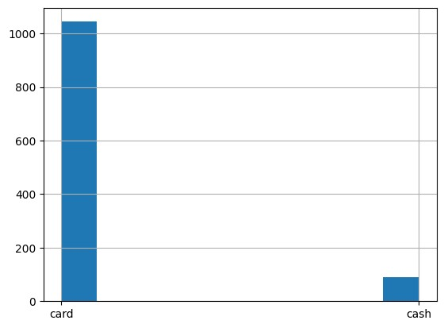

|  |  |  |  |  |  |  |  |  |  |  |  |  |
| --- | --- | --- | --- | --- | --- | --- | --- | --- | --- | --- | --- | --- |
| **pd.DataFrame(coffee_data['coffee_name'].value_counts(normalize= True).sort_values(ascending=False).round(4)*100)**  **Out[12]:**   |  |  | | --- | --- | |  | **propo**  **rtion** | | **coffee_nam e** |  | | **Americano with Milk** | **23.65** | | **Latte** | **21.45** | | **Cappuccino** | **17.30** | | **Americano** | **14.92** | |

|  |  |  |  |  |  |  |  |  |
| --- | --- | --- | --- | --- | --- | --- | --- | --- |
| |  |  | | --- | --- | | **Cortado** | **8.74** | | **Hot**  **Chocolate** | **6.53** | | **Espresso** | **4.32** | | **Cocoa** | **3.09** |   **Americano with Milk and Latte are our most popular coffee products. In the second tier are Cappuccino and Americano, while Cortado, Hot Chocolate, Espresso, and Cocoa are less popular.**  **Next, let's conduct data transformations for further analysis.**  **In [13]:**  ***#Convert date and datetime to datetme format* coffee_data['date']=pd.to_datetime(coffee_data['date']) coffee_data['datetime']=pd.to_datetime(coffee_data['datetime'])**  ***#Create column of Month, Weekdays, and Hours* coffee_data['month']=coffee_data['date'].dt.strftime('%Y-%m') coffee_data['day']=coffee_data['date'].dt.strftime('%w') coffee_data['hour']=coffee_data['datetime'].dt.strftime('%H')** |

|  |
| --- |
| **In [14]: coffee_data.info()**  **<class 'pandas.core.frame.DataFrame'>**  **RangeIndex: 1133 entries, 0 to 1132 Data columns (total 9 columns):**  **# Column Non-Null Count Dtype**  **--- ------ -------------- -----**   1. **date 1133 non-null datetime64[ns]** 2. **datetime 1133 non-null datetime64[ns]** 3. **cash_type 1133 non-null object** 4. **card 1044 non-null object** 5. **money 1133 non-null float64** 6. **coffee_name 1133 non-null object** 7. **month 1133 non-null object** 8. **day 1133 non-null object 8 hour 1133 non-null object**   **dtypes: datetime64[ns](2), float64(1), object(6) memory usage: 79.8+ KB**  **In [15]:** |

**coffee_data.head()**

**Out[15]:**

|  |  |  |  |  |  |  |  |  |  |
| --- | --- | --- | --- | --- | --- | --- | --- | --- | --- |
|  | **date** | **datetime** | **cash**  **_type** | **card** | **mo**  **ney** | **coffee_ name** | **mon**  **th** | **d a y** | **h o**  **ur** |
| **0** | **2024-**  **03-01** | **2024-03-01**  **10:15:50.520** | **card** | **ANON-0000-**  **0000-0001** | **38.**  **7** | **Latte** | **202 4-03** | **5** | **10** |
| **1** | **2024-**  **03-01** | **2024-03-01**  **12:19:22.539** | **card** | **ANON-0000-**  **0000-0002** | **38.**  **7** | **Hot Chocol ate** | **202 4-03** | **5** | **12** |
| **2** | **2024-**  **03-01** | **2024-03-01**  **12:20:18.089** | **card** | **ANON-0000-**  **0000-0002** | **38.**  **7** | **Hot Chocol ate** | **202 4-03** | **5** | **12** |
| **3** | **2024-**  **03-01** | **2024-03-01**  **13:46:33.006** | **card** | **ANON-0000-**  **0000-0003** | **28.**  **9** | **Americ ano** | **202 4-03** | **5** | **13** |

**4**

**2024-**

**03-01**

**2024-03-01**

**13:48:14.626**

**card**

**ANON-0000-**

**0000-0004**

**38.**

**7**

**Latte**

**202**

**4-03**

**5**

**13**

**In**

**[16]:**

**[**

**coffee_data**

**[**

**'date'**

**]**

**.**

**min(),coffee_data[**

**'date'**

**]**

**.**

**max()]**

**Out[16]:**

**[**

**Timestamp**

**('2024-03-01**

**00:00:00')**

**,**

**Timestamp('2024-07-31**

**00:00:00')]**

**The**

**time**

**range**

**of**

**this**

**data**

**set**

**is**

**from**

**2023-3-1**

**to**

**2024-7-31**

**Let's**

**first**

**check**

**the**

**overal**

**revenue**

**by**

**products.**

**In**

**[17]:**

**revenue_data**

**=**

**coffee_data**

**.**

**groupby([**

**'coffee_name'**

**])**

**.**

**sum([**

**'money'**

**])**

**.**

**reset_index**

**()**

**.**

**sort_values(by**

**=**

**'money'**

**,ascending**

**=**

**False**

**)**

**In**

**[18]:**

**plt**

**.**

**figure(figsize**

**=**

**(**

**10**

**,**

**4**

**))**

**ax**

**=**

**sns**

**.**

**barplot(data**

**=**

**revenue_data,x**

**=**

**'money'**

**,y**

**=**

**'coffee_name'**

**,color**

**=**

**'**

**steelblue'**

**)**

**ax**

**.**

**bar_label(ax**

**.**

**containers[**

**0**

**]**

**,**

**fontsize**

**=**

**6**

**)**

**plt**

**.**

**xlabel(**

**'Revenue'**

**)**

**Out[18]:**

**Text(0.5,**

**0**

**,**

**'Revenue')**

**Latte**

**is**

**the**

**product**

**with**

**the**

**highest**

**revenue,**

**while**

**Expresso**

**is**

**the**

**one**

**at**

**the**

**bottom.**

**Then**

**let's**

**check**

**the**

**monthly**

**data.**

**In**

**[19]:**

**monthly_sales**

**=**

**coffee_data**

**.**

**groupby([**

**'coffee_name'**

**,**

**'month'**

**])**

**.**

**count()[**

**'date'**

**]**

**.**

**re**

**set_index()**

**.**

**rename(columns**

**=**

**{**

**'date'**

**:**

**'count'**

**})**

**.**

**pivot(index**

**=**

**'month**

**'**

**,columns**

**=**

**'coffee_name'**

**,values**

**=**

**'count'**

**)**

**.**

**reset_index()**

**monthly_sales**

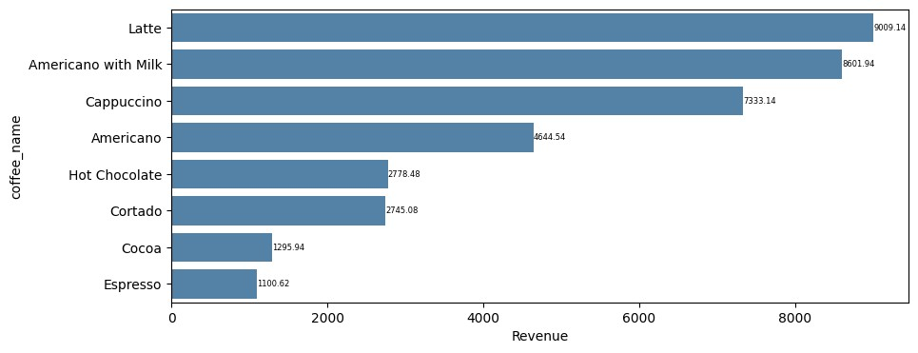

**Out[19]:**

|  |  |  |  |  |  |  |  |  |  |
| --- | --- | --- | --- | --- | --- | --- | --- | --- | --- |
| coffee_ name | mont h | Ameri cano | Americano with Milk | Cappu  ccino | Co coa | Cort ado | Espr esso | Hot Chocola te | Lat te |
| 0 | 2024  -03 | 36 | 34 | 20 | 6 | 30 | 10 | 22 | 48 |
| 1 | 2024  -04 | 35 | 42 | 43 | 6 | 19 | 7 | 13 | 31 |
| 2 | 2024  -05 | 48 | 58 | 55 | 9 | 17 | 8 | 14 | 58 |
| 3 | 2024  -06 | 14 | 69 | 46 | 5 | 19 | 10 | 14 | 50 |
| 4 | 2024 | 36 | 65 | 32 | 9 | 14 | 14 | 11 | 56 |

|  |  |  |  |  |  |  |  |  |  |  |  |  |  |  |  |
| --- | --- | --- | --- | --- | --- | --- | --- | --- | --- | --- | --- | --- | --- | --- | --- |
| -07  **In [20]: monthly_sales.describe().T.loc[:,['min','max']]**  **Out[20]:**   |  |  |  | | --- | --- | --- | |  | **mi n** | **m**  **ax** | | **coffee_nam e** |  |  | | **Americano** | **14**  **.0** | **48**  **.0** | | **Americano with Milk** | **34**  **.0** | **69**  **.0** | | **Cappuccino** | **20**  **.0** | **55**  **.0** | |

|  |  |  |  |  |  |  |  |  |  |  |  |  |  |  |  |
| --- | --- | --- | --- | --- | --- | --- | --- | --- | --- | --- | --- | --- | --- | --- | --- |
| |  |  |  | | --- | --- | --- | | **Cocoa** | **5.**  **0** | **9.**  **0** | | **Cortado** | **14**  **.0** | **30**  **.0** | | **Espresso** | **7.**  **0** | **14**  **.0** | | **Hot**  **Chocolate** | **11**  **.0** | **22**  **.0** | | **Latte** | **31**  **.0** | **58**  **.0** |   **In [21]:**  **plt.figure(figsize=(12,6)) sns.lineplot(data=monthly_sales) plt.legend(loc='upper left') plt.xticks(range(len(monthly_sales['month'])),monthly_sales['mo nth'],size='small')** |

**Out[21]:**

**([<matplotlib.axis.XTick at 0x7d45ae8a0430>,**

**<matplotlib.axis.XTick at 0x7d45ae8a0400>,**

**<matplotlib.axis.XTick at 0x7d45ae8a2ef0>,**

**<matplotlib.axis.XTick at 0x7d45ae8d3ee0>,**

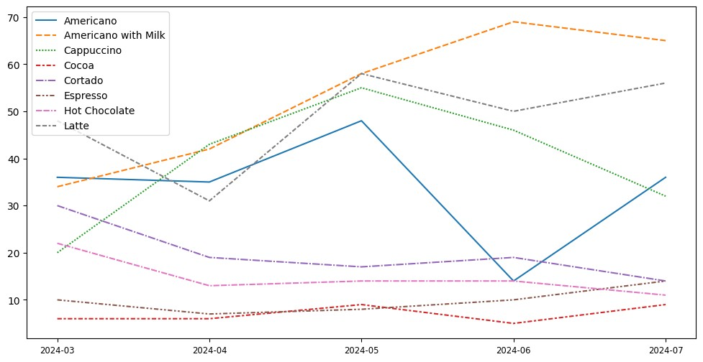**<matplotlib.axis.XTick at 0x7d45ae9149d0>],**

**[Text(0, 0, '2024-03'),**

**Text(1, 0, '2024-04'),**

**Text(2, 0, '2024-05'),**

**Text(3, 0, '2024-06'),**

**Text(4, 0, '2024-07')])**

|  |  |  |  |  |  |  |  |  |  |
| --- | --- | --- | --- | --- | --- | --- | --- | --- | --- |
| **As shown in the line chart above, Americano with Milk and Latte, and Cappuccino are top selling coffee types, while Cocoa and Expresso have lowest sales. Additionally, Americano with Milk and Latte show an upward trending.**  **In [22]:**  **weekday_sales = coffee_data.groupby(['day']).count()['date'].reset_index().rena me(columns={'date':'count'}) weekday_sales**  **Out[22]:**   |  |  |  | | --- | --- | --- | |  | **d a y** | **co unt** | | **0** | **0** | **15**  **1** | | **1** | **1** | **15**  **1** | |

|  |  |  |  |  |  |  |  |  |  |  |  |  |  |  |  |
| --- | --- | --- | --- | --- | --- | --- | --- | --- | --- | --- | --- | --- | --- | --- | --- |
| |  |  |  | | --- | --- | --- | | **2** | **2** | **18**  **5** | | **3** | **3** | **16**  **5** | | **4** | **4** | **16**  **4** | | **5** | **5** | **16**  **3** | | **6** | **6** | **15**  **4** |   **In [23]:**  **plt.figure(figsize=(12,6)) sns.barplot(data=weekday_sales,x='day',y='count',color='steelbl ue') plt.xticks(range(len(weekday_sales['day'])),['Sun','Mon','Tue',**  **'Wed','Thur','Fri','Sat'],size='small')** |

|  |
| --- |
| **Out[23]:**  **([<matplotlib.axis.XTick at 0x7d45aea5b070>,**  **<matplotlib.axis.XTick at 0x7d45aea5b040>,**  **<matplotlib.axis.XTick at 0x7d45aea5af50>,**  **<matplotlib.axis.XTick at 0x7d45aeaa1240>,**  **<matplotlib.axis.XTick at 0x7d45aeaa1cf0>,**  **<matplotlib.axis.XTick at 0x7d45cf8c5f00>,**  **<matplotlib.axis.XTick at 0x7d45aeaa29b0>],**  **[Text(0, 0, 'Sun'),**  **Text(1, 0, 'Mon'),**  **Text(2, 0, 'Tue'),**  **Text(3, 0, 'Wed'),**  **Text(4, 0, 'Thur'),**  **Text(5, 0, 'Fri'),**  **Text(6, 0, 'Sat')])** |

**The**

**bar**

**chart**

**reveals**

**that**

**Tuesday**

**has**

**the**

**highest**

**sales**

**of**

**the**

**week,**

**while**

**sales**

**on**

**the**

**other**

**days**

**are**

**relatively**

**similar.**

**In**

**[24]:**

**daily_sales**

**=**

**coffee_data**

**.**

**groupby([**

**'coffee_name'**

**,**

**'date'**

**])**

**.**

**count()[**

**'datetime'**

**]**

**.**

**reset_index()**

**.**

**reset_index()**

**.**

**rename(columns**

**=**

**{**

**'datetime'**

**:**

**'count'**

**})**

**.**

**pivot(index**

**=**

**'date'**

**,columns**

**=**

**'coffee_name'**

**,values**

**=**

**'count'**

**)**

**.**

**res**

**et_index()**

**.**

**fillna(**

**0**

**)**

**daily_sales**

**Out[24]:**

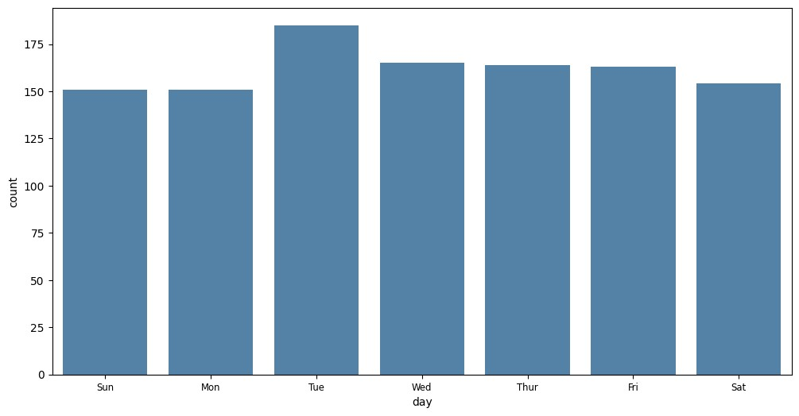

|  |  |  |  |  |  |  |  |  |  |  |  |  |  |  |  |  |  |  |  |  |  |  |  |  |  |  |  |  |  |  |  |  |  |  |  |  |  |  |  |  |  |  |  |  |  |  |  |  |  |  |  |  |  |  |  |  |  |  |  |  |  |  |  |  |  |  |  |  |  |  |
| --- | --- | --- | --- | --- | --- | --- | --- | --- | --- | --- | --- | --- | --- | --- | --- | --- | --- | --- | --- | --- | --- | --- | --- | --- | --- | --- | --- | --- | --- | --- | --- | --- | --- | --- | --- | --- | --- | --- | --- | --- | --- | --- | --- | --- | --- | --- | --- | --- | --- | --- | --- | --- | --- | --- | --- | --- | --- | --- | --- | --- | --- | --- | --- | --- | --- | --- | --- | --- | --- | --- |
| |  |  |  |  |  |  |  |  |  |  | | --- | --- | --- | --- | --- | --- | --- | --- | --- | --- | | coffee_ name | date | Ameri cano | Americano with Milk | Cappu  ccino | Co coa | Cort ado | Espr esso | Hot Chocola te | La tte | | 0 | 2024-  03-01 | 1.0 | 4.0 | 0.0 | 1.0 | 0.0 | 0.0 | 3.0 | 2.  0 | | 1 | 2024-  03-02 | 3.0 | 3.0 | 0.0 | 0.0 | 0.0 | 0.0 | 0.0 | 1.  0 | | 2 | 2024-  03-03 | 1.0 | 2.0 | 0.0 | 1.0 | 2.0 | 0.0 | 2.0 | 2.  0 | | 3 | 2024-  03-04 | 0.0 | 1.0 | 0.0 | 0.0 | 0.0 | 1.0 | 0.0 | 2.  0 | | 4 | 2024-  03-05 | 0.0 | 0.0 | 0.0 | 1.0 | 1.0 | 0.0 | 4.0 | 3.  0 | | ... | ... | ... | ... | ... | ... | ... | ... | ... | ... | |

|  |  |  |  |  |  |  |  |  |  |  |  |  |  |  |  |  |  |  |  |  |  |  |  |  |  |  |  |  |  |  |  |  |  |  |  |  |  |  |  |  |  |  |  |  |  |  |  |  |  |  |
| --- | --- | --- | --- | --- | --- | --- | --- | --- | --- | --- | --- | --- | --- | --- | --- | --- | --- | --- | --- | --- | --- | --- | --- | --- | --- | --- | --- | --- | --- | --- | --- | --- | --- | --- | --- | --- | --- | --- | --- | --- | --- | --- | --- | --- | --- | --- | --- | --- | --- | --- |
| |  |  |  |  |  |  |  |  |  |  | | --- | --- | --- | --- | --- | --- | --- | --- | --- | --- | | 145 | 2024-  07-27 | 0.0 | 5.0 | 4.0 | 0.0 | 0.0 | 2.0 | 0.0 | 2.  0 | | 146 | 2024-  07-28 | 0.0 | 1.0 | 0.0 | 0.0 | 0.0 | 1.0 | 0.0 | 1.  0 | | 147 | 2024-  07-29 | 3.0 | 2.0 | 2.0 | 1.0 | 0.0 | 0.0 | 2.0 | 1.  0 | | 148 | 2024-  07-30 | 2.0 | 12.0 | 2.0 | 0.0 | 3.0 | 2.0 | 0.0 | 3.  0 | | 149 | 2024-  07-31 | 2.0 | 6.0 | 1.0 | 2.0 | 4.0 | 0.0 | 0.0 | 7.  0 |   **150 rows × 9 columns**  **In [25]: daily_sales.iloc[:,1:].describe().T.loc[:,['min','max']]**  **Out[25]:** |

|  |  |  |  |  |  |  |  |  |  |  |  |  |  |  |  |  |  |  |  |  |  |
| --- | --- | --- | --- | --- | --- | --- | --- | --- | --- | --- | --- | --- | --- | --- | --- | --- | --- | --- | --- | --- | --- |
| |  |  |  | | --- | --- | --- | |  | **m in** | **m**  **ax** | | **coffee_nam e** |  |  | | **Americano** | **0.**  **0** | **5.**  **0** | | **Americano with Milk** | **0.**  **0** | **12**  **.0** | | **Cappuccino** | **0.**  **0** | **9.**  **0** | | **Cocoa** | **0.**  **0** | **2.**  **0** | | **Cortado** | **0.**  **0** | **4.**  **0** | |

|  |  |  |  |  |  |  |  |  |  |  |  |  |
| --- | --- | --- | --- | --- | --- | --- | --- | --- | --- | --- | --- | --- |
| |  |  |  | | --- | --- | --- | | **Espresso** | **0.**  **0** | **4.**  **0** | | **Hot**  **Chocolate** | **0.**  **0** | **4.**  **0** | | **Latte** | **0.**  **0** | **7.**  **0** |   **This table provides us the infomation of how many of each products can be sold in each day.**  **In [26]:**  **hourly_sales = coffee_data.groupby(['hour']).count()['date'].reset_index().ren ame(columns={'date':'count'}) hourly_sales**  **Out[26]:**   |  |  |  | | --- | --- | --- | |  | **ho ur** | **co unt** | |

|  |  |  |  |  |  |  |  |  |  |  |  |  |  |  |  |  |  |  |  |  |  |  |  |  |
| --- | --- | --- | --- | --- | --- | --- | --- | --- | --- | --- | --- | --- | --- | --- | --- | --- | --- | --- | --- | --- | --- | --- | --- | --- |
| |  |  |  | | --- | --- | --- | | **0** | **07** | **13** | | **1** | **08** | **44** | | **2** | **09** | **50** | | **3** | **10** | **13**  **3** | | **4** | **11** | **10**  **3** | | **5** | **12** | **87** | | **6** | **13** | **78** | | **7** | **14** | **76** | |

|  |  |  |  |  |  |  |  |  |  |  |  |  |  |  |  |  |  |  |  |  |  |
| --- | --- | --- | --- | --- | --- | --- | --- | --- | --- | --- | --- | --- | --- | --- | --- | --- | --- | --- | --- | --- | --- |
| |  |  |  | | --- | --- | --- | | **8** | **15** | **65** | | **9** | **16** | **77** | | **1**  **0** | **17** | **77** | | **1**  **1** | **18** | **75** | | **1**  **2** | **19** | **96** | | **1**  **3** | **20** | **54** | | **1**  **4** | **21** | **70** | |

**1**

**5**

**22**

**35**

**In**

**[27]:**

**sns**

**.**

**barplot(data**

**=**

**hourly_sales,x**

**=**

**'hour'**

**,y**

**=**

**'count'**

**,color**

**=**

**'steelbl**

**ue'**

**)**

**Out[27]:**

**<**

**Axes**

**:**

**xlabel='hour',**

**ylabel='count'>**

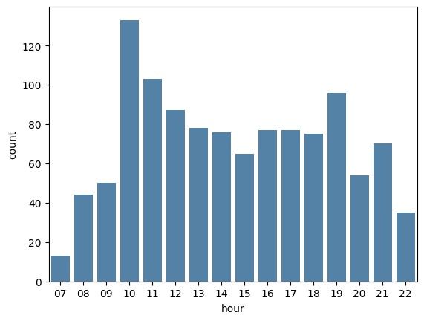

|  |  |  |  |  |  |  |  |  |  |  |  |  |  |  |  |  |  |  |  |  |  |  |  |  |  |  |  |  |  |  |  |  |  |  |  |  |  |  |  |  |
| --- | --- | --- | --- | --- | --- | --- | --- | --- | --- | --- | --- | --- | --- | --- | --- | --- | --- | --- | --- | --- | --- | --- | --- | --- | --- | --- | --- | --- | --- | --- | --- | --- | --- | --- | --- | --- | --- | --- | --- | --- |
| **Overall, two peak hours within each day can be observed: 10:00am and 7:00pm. Then, let's check if any difference for different products.**  **In [28]:**  **hourly_sales_by_coffee = coffee_data.groupby(['hour','coffee_name']).count()['date'].res et_index().rename(columns={'date':'count'}).pivot(index='hour', columns='coffee_name',values='count').fillna(0).reset_index() hourly_sales_by_coffee**  **Out[28]:**   |  |  |  |  |  |  |  |  |  |  | | --- | --- | --- | --- | --- | --- | --- | --- | --- | --- | | coffee_ name | ho ur | Ameri cano | Americano with Milk | Cappu  ccino | Coc oa | Cort ado | Espre sso | Hot Chocolat e | Lat te | | 0 | 07 | 5.0 | 4.0 | 1.0 | 0.0 | 1.0 | 0.0 | 0.0 | 2.0 | | 1 | 08 | 10.0 | 7.0 | 8.0 | 1.0 | 6.0 | 0.0 | 0.0 | 12.  0 | | 2 | 09 | 8.0 | 16.0 | 6.0 | 1.0 | 5.0 | 3.0 | 0.0 | 11. | |

|  |  |  |  |  |  |  |  |  |  |  |  |  |  |  |  |  |  |  |  |  |  |  |  |  |  |  |  |  |  |  |  |  |  |  |  |  |  |  |  |  |  |  |  |  |  |  |  |  |  |  |  |  |  |  |  |  |  |  |  |  |  |  |  |  |  |  |  |  |  |  |
| --- | --- | --- | --- | --- | --- | --- | --- | --- | --- | --- | --- | --- | --- | --- | --- | --- | --- | --- | --- | --- | --- | --- | --- | --- | --- | --- | --- | --- | --- | --- | --- | --- | --- | --- | --- | --- | --- | --- | --- | --- | --- | --- | --- | --- | --- | --- | --- | --- | --- | --- | --- | --- | --- | --- | --- | --- | --- | --- | --- | --- | --- | --- | --- | --- | --- | --- | --- | --- | --- | --- |
| |  |  |  |  |  |  |  |  |  |  | | --- | --- | --- | --- | --- | --- | --- | --- | --- | --- | |  |  |  |  |  |  |  |  |  | 0 | | 3 | 10 | 20.0 | 31.0 | 10.0 | 4.0 | 8.0 | 2.0 | 7.0 | 51.  0 | | 4 | 11 | 21.0 | 25.0 | 16.0 | 1.0 | 13.0 | 6.0 | 8.0 | 13.  0 | | 5 | 12 | 14.0 | 26.0 | 15.0 | 3.0 | 7.0 | 6.0 | 3.0 | 13.  0 | | 6 | 13 | 18.0 | 18.0 | 10.0 | 2.0 | 12.0 | 3.0 | 4.0 | 11.  0 | | 7 | 14 | 15.0 | 18.0 | 13.0 | 4.0 | 6.0 | 5.0 | 2.0 | 13.  0 | | 8 | 15 | 14.0 | 15.0 | 8.0 | 0.0 | 3.0 | 4.0 | 6.0 | 15.  0 | |

|  |  |  |  |  |  |  |  |  |  |  |  |  |  |  |  |  |  |  |  |  |  |  |  |  |  |  |  |  |  |  |  |  |  |  |  |  |  |  |  |  |  |  |  |  |  |  |  |  |  |  |  |  |  |  |  |  |  |  |  |  |  |  |  |  |  |  |  |  |  |  |
| --- | --- | --- | --- | --- | --- | --- | --- | --- | --- | --- | --- | --- | --- | --- | --- | --- | --- | --- | --- | --- | --- | --- | --- | --- | --- | --- | --- | --- | --- | --- | --- | --- | --- | --- | --- | --- | --- | --- | --- | --- | --- | --- | --- | --- | --- | --- | --- | --- | --- | --- | --- | --- | --- | --- | --- | --- | --- | --- | --- | --- | --- | --- | --- | --- | --- | --- | --- | --- | --- | --- |
| |  |  |  |  |  |  |  |  |  |  | | --- | --- | --- | --- | --- | --- | --- | --- | --- | --- | | 9 | 16 | 10.0 | 18.0 | 12.0 | 3.0 | 12.0 | 5.0 | 4.0 | 13.  0 | | 10 | 17 | 9.0 | 11.0 | 18.0 | 4.0 | 6.0 | 4.0 | 7.0 | 18.  0 | | 11 | 18 | 9.0 | 16.0 | 12.0 | 2.0 | 5.0 | 5.0 | 10.0 | 16.  0 | | 12 | 19 | 5.0 | 18.0 | 34.0 | 2.0 | 5.0 | 1.0 | 9.0 | 22.  0 | | 13 | 20 | 1.0 | 12.0 | 13.0 | 6.0 | 5.0 | 3.0 | 6.0 | 8.0 | | 14 | 21 | 5.0 | 25.0 | 13.0 | 1.0 | 3.0 | 1.0 | 3.0 | 19.  0 | | 15 | 22 | 5.0 | 8.0 | 7.0 | 1.0 | 2.0 | 1.0 | 5.0 | 6.0 |   **In [29]:** |

|  |
| --- |
| **fig, axs = plt.subplots(2, 4, figsize=(20, 10))**  ***# Flatten the array of subplots for easy iteration* axs = axs.flatten()**  ***# Loop through each column in the DataFrame, skipping the***  ***'Index' column* for i, column in enumerate(hourly_sales_by_coffee.columns[1:]):**  ***# Skip the first column ('Index')* axs[i].bar(hourly_sales_by_coffee['hour'],**  **hourly_sales_by_coffee[column]) axs[i].set_title(f'{column}') axs[i].set_xlabel('Hour')**  ***#axs[i].set_ylabel('Sales')* plt.tight_layout()**  ***# Show the plot* plt.show()** |

**The**

**plots**

**above**

**illustrate**

**the**

**shopping**

**traffic**

**for**

**each**

**product**

**throughout**

**the**

**day.**

**Notably,**

**all**

**products**

**experience**

**a**

**peak**

**in**

**traffic**

**around**

**10:00**

**AM,**

**with**

**this**

**trend**

**being**

**particularly**

**pronounced**

**for**

**Latte.**

**Additionally,**

**Cappuccino,**

**Cocoa,**

**and**

**Hot**

**Chocolate**

**tend**

**to**

**be**

**more**

**popular**

**during**

**the**

**evening**

**hours,**

**specifically**

**between**

**6:00**

**pm**

**and**

**pm.**

**8:00**

Conclusion

**From**

**the**

**analysis**

**above,**

**we**

**have**

**uncovered**

**valuable**

**insights**

**into**

**customer**

**shopping**

**patterns**

**on**

**a**

**daily**

**and**

**weekly**

**basis.**

**We**

**have**

**identified**

**the**

**most**

**popular**

**coffee**

**products**

**and**

**observed**

**the**

**shopping**

**trends**

**over**

**time.**

**These**

**findings**

**are**

**instrumental**

**in**

**optimizing**

**inventory**

**planning,**

**designing**

**the**

**layout**

**of**

**vending**

**machines,**

**and**

**determining**

**the**

**ideal**

**restock**

**times**

**for**

**coffee**

**products.**

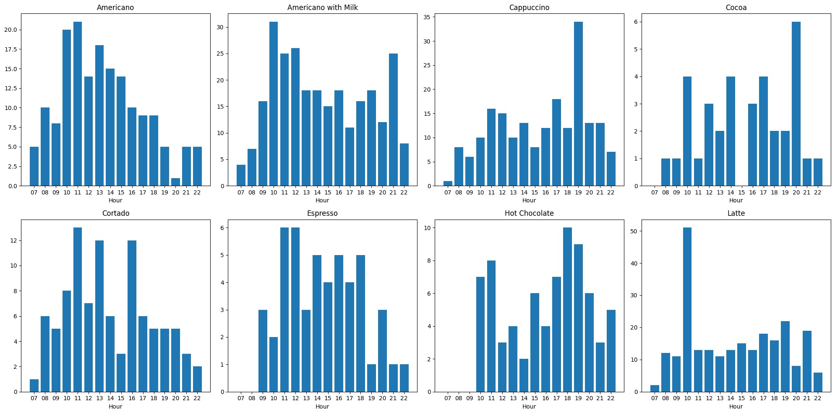

[Reference](https://github.com/Hari-Vijayaraghavan96/Coffee-Shop-Sales-Analysis) [link](https://github.com/Hari-Vijayaraghavan96/Coffee-Shop-Sales-Analysis)